# Report for Dean Moffitt (2024-10-01 to 2024-10-31)

Average Bat Speed: 47.98

Average Rotational Acceleration: 4.90

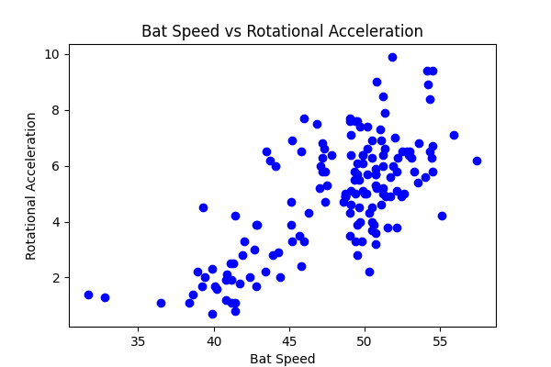

## Comments

Add comments here...